R. Reports Menu: 7. Daybook

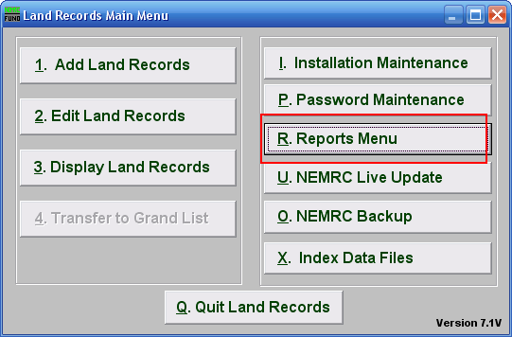
Click on “R. Reports Menu” from the Main Menu and the following window will appear:

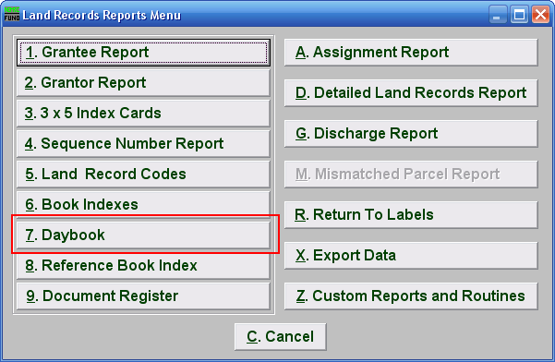
Click on “7. Daybook” from the Reports Menu and the following window will appear:
Daybook

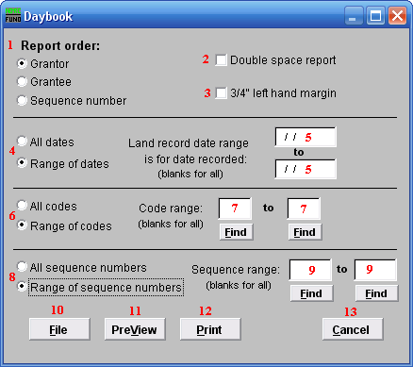

- Report order: Select the order to print the cards in: Sequence Number is an assigned entry number order by the system, Grantor/Grantee is based upon the name as entered on those lines, Book and page use the references made on the record.

- Double space report: Click this box to have this report be double-spaced instead of single-spaced. This is for marking up or visual appearance.

- 3/4" left hand margin: Check this box to have the system create a three quarter inch left margin for binding of the report.

- All OR Range of dates: Select to print for all dates or a range of recorded dates.

- Land record date range is for date recorded: Enter the beginning and ending date range for data to report. Leaving these fields empty will result in all available data being selected.

- All OR Range of codes: Select the choice of reporting on all codes or a specific range of codes.

- Code range: Enter a specific range of codes to report or leave these fields empty to report on all codes. You may pick your start and ending ranges from a list by using the find button

- All OR Range of sequence numbers: Select to print for all system assigned sequence numbers or a specific range of sequence numbers.

- Sequence range: Enter the range of sequence numbers to report or pick the starting and ending range from a list by using the find button.

- File: Click this button to save this report on this computer. Refer to GENERAL FILE for more information.

- PreView: Click this button to preview this report. Refer to GENERAL PREVIEW for more information.

- Print: Click this button to print this report. Refer to GENERAL PRINTING for more information.

- Cancel: Click this button to cancel and return to the previous screen.

